**­BelugaCDN Admin-Panel Overview**

While clients have the ability to change configurations at the click of a button, the admin-panel is a bit more of an involved process. Configurations of all new properties are generated in JavaScript object Notation ([JSON](https://www.w3schools.com/js/js_json_syntax.asp) format).   
  
[**https://www-admin.belugacdn.com/**](https://www-admin.belugacdn.com/)

**Home Page**

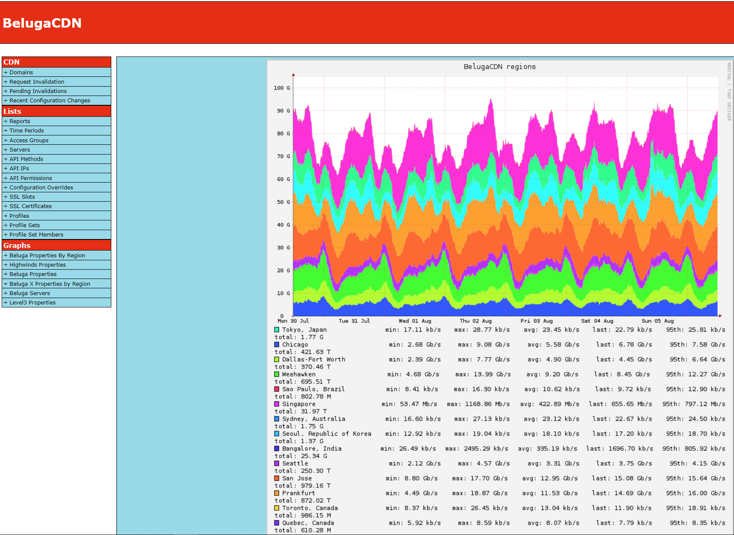

This is the screen you will be greeted with upon logging in. On the left you have tabs which are dynamic, they may change according to the content you’re viewing on your screen. The colorful graph is a breakdown of overall traffic per region on the CDN.

**CDN 🡪 Domains** (<https://www-admin.belugacdn.com/list/domains>)

This page will display all CDN properties. From here you can click on the property name to view traffic/error information or to even view/edit the properties configuration.

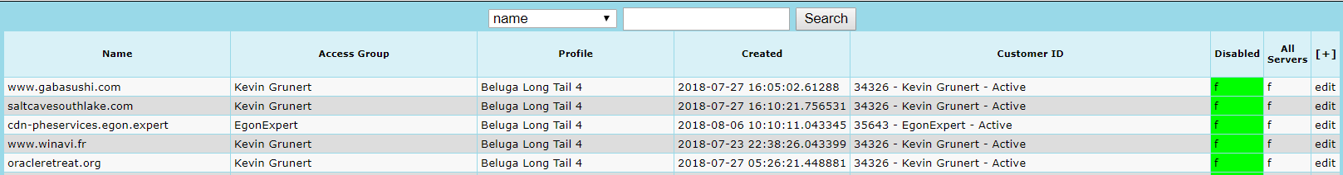

By clicking on a property’s “Access Group” name, it will display ALL properties belong to that client or also known as CID group. (quick note: Each client is associated with a Client ID aka CID number). Access Group view will also display the overall traffic graphs for a client’s properties.

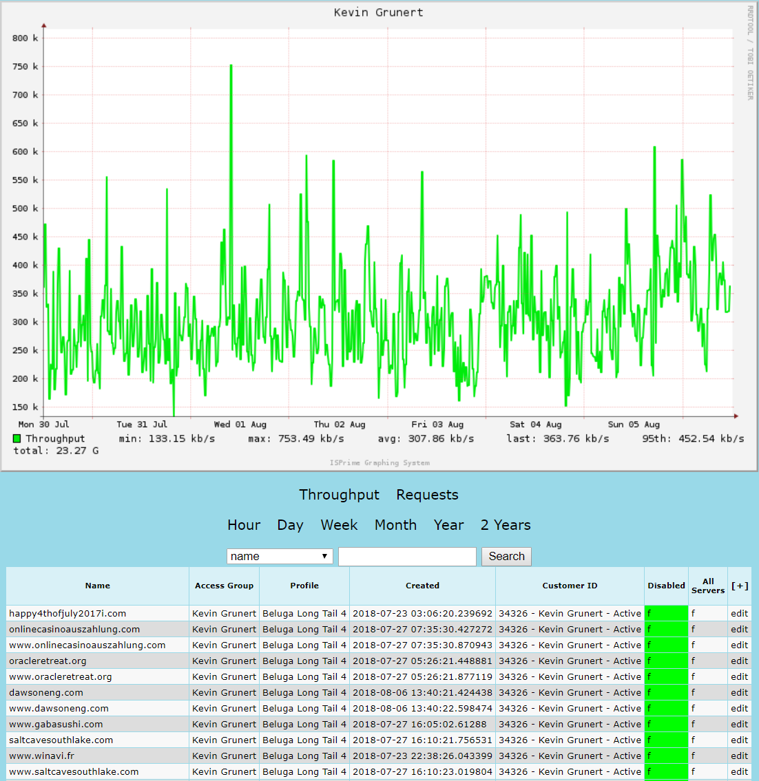

(image clipped from: <https://www-admin.belugacdn.com/list/domains/search/access_group_id/705>)

Upon clicking on a specific property, for example: <https://www-admin.belugacdn.com/property/21605>, you will notice there are traffic graphs specific to that property.

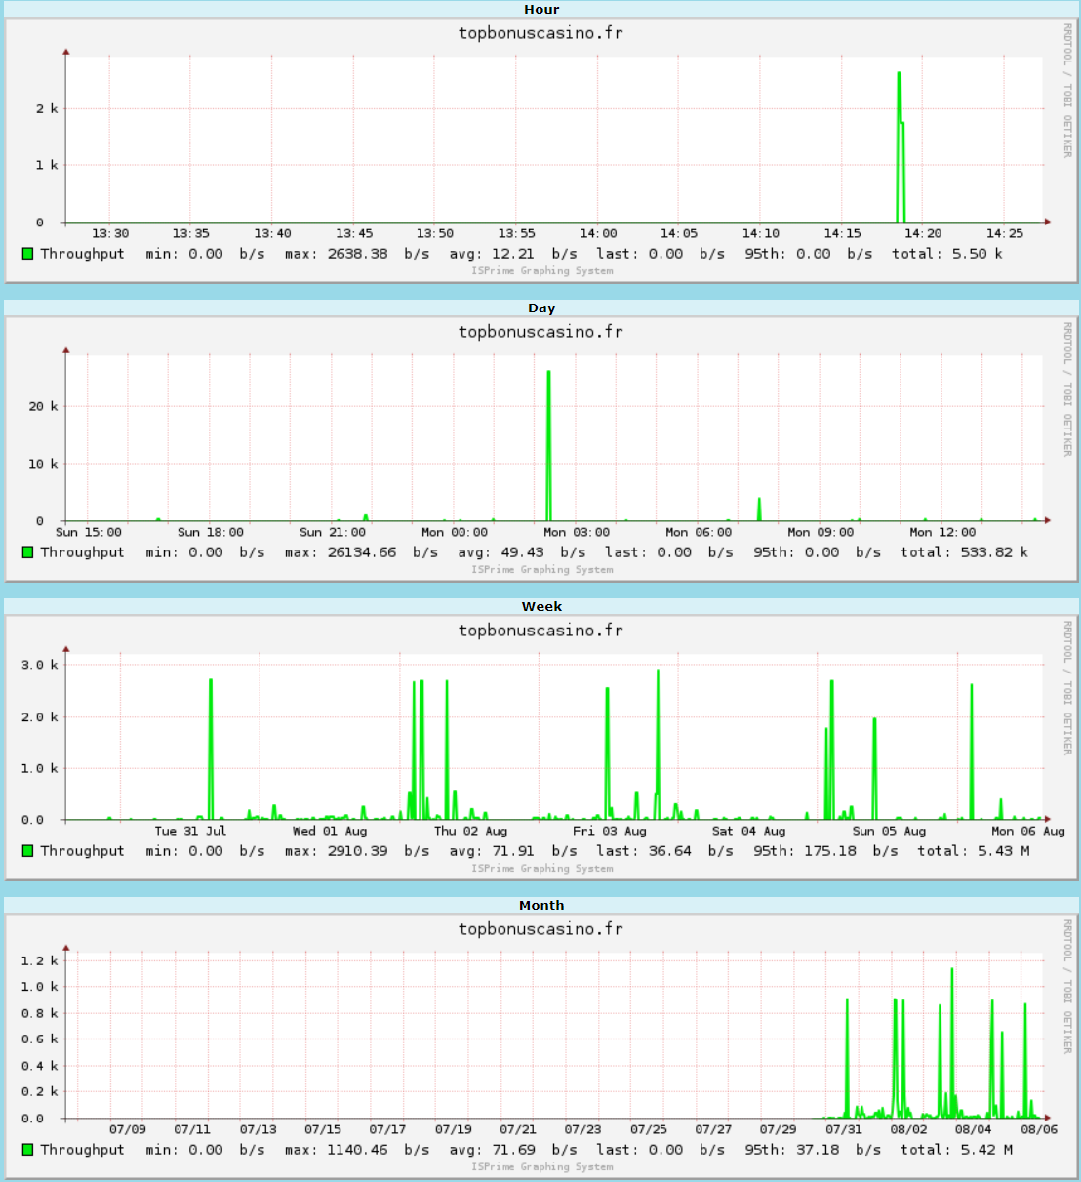

On the left you will notice an extra array of views and tabs:

For Example: “Property” tabs will allow you to assign profiles, enable extra regions, view metrics and see usage history.

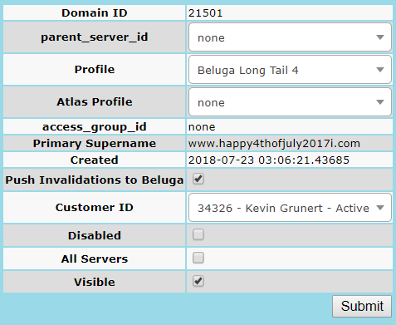

Additionally, the Configuration tab will allow you to configure the property’s actions, such as adding/removing features and over all behavior of to respond to client requests.

This is an example of a basic property with no additional features or rules added: <https://www-admin.belugacdn.com/property/12537/configuration>

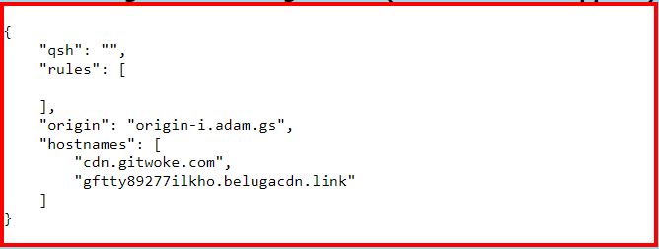

**Graphs**

Graphs are an extremely important aspect of the CDN. They allow us to visualize parsed metrics to piece together how a property/server is behaving. All graph images can be broken down by unix timestamps, you can utilize: <https://www.unixtimestamp.com>

If a client changes a configuration and you see a drop in traffic, that is an instant indication that there may be an error. On the contrary if there is a regular pattern of traffic/requests on a property and with no changes on the CDN you notice a sudden drop or spike of traffic, that’s an indication that there may be an issue on the client origin.

**Traffic**: How much bandwidth is a current property doing (Direct URL to Image can be altered for different views: <https://www-admin.belugacdn.com/graph/property/2829/hour/wide/throughput.png>)

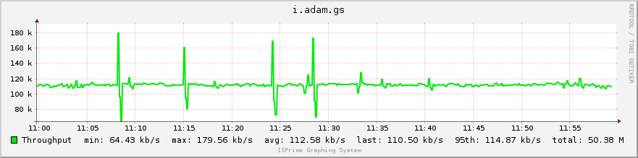

**Requests:**